**Plugging into the Future: An Exploration of Electricity Consumption Patterns Using Tableau**

**Project Description:**  
Plugging into the Future: An Exploration of Electricity Consumption Patterns using Tableau" is a project that leverages Tableau's data visualization capabilities to analyze and understand electricity consumption patterns across various regions and sectors. By examining data such as time-of-day usage, peak demand periods, seasonal variations, and consumption by sector (residential, commercial, industrial), the project aims to provide valuable insights for utility companies, policymakers, and consumers. These insights can help optimize electricity usage, improve grid management, and promote sustainable energy practices.

Scenario 1: Time-of-Day Usage Patterns  
The visualization tool allows users to explore electricity consumption trends throughout the day, across different regions and sectors. By identifying peak usage times and low-demand periods, utility companies can better manage electricity supply and demand, and design incentives for off-peak usage.

Scenario 2: Seasonal Variations and Forecasting  
The project uses Tableau to analyze seasonal variations in electricity consumption patterns. Understanding how usage fluctuates throughout the year can help stakeholders plan for seasonal peaks and troughs, ensuring reliable power supply and optimizing energy production from renewable sources.

Scenario 3: Sector-Specific Consumption Insights  
Through data visualization, the project explores electricity consumption by different sectors such as residential, commercial, and industrial. This analysis can reveal which sectors are the largest consumers of electricity and how their usage patterns differ. Utility companies can use this information to tailor conservation programs and energy efficiency initiatives to specific sectors for more effective energy management.

**Data Collection & Extraction from Database**

Data collection is the process of gathering and measuring information on variables of interest, in an established systematic fashion that enables one to answer stated research questions, test hypotheses, and evaluate outcomes and generate insights from the data.

**Dataset:**

In Dataset Consumption.csv data is in the form of a time series for a period of 24 months beginning from 2nd Jan 2019 till 5th December 2020. Columns contains States, Regions, Latitude, Longitude, Dates andUsage. The dataset has been scraped from the weekly energy reports of POSOC.  
Fields Include   
States - Indian States  
Regions- States in Regions on Indian Map  
Latitude - States in Regions on Indian Map  
Longitude - Geographical Coordinates of States  
Dates - Dates of Usage  
Usage - Power consumed in Mega Units(MU)

|  |  |  |  |  |  |
| --- | --- | --- | --- | --- | --- |
| **States** | **Regions** | **latitude** | **longitude** | **Dates** | **Usage** |
| Punjab | NR | 31.51997 | 75.98 | 02-01-2019 | 119.9 |
| Haryana | NR | 28.45001 | 77.01999 | 02-01-2019 | 130.3 |
| Rajasthan | NR | 26.45 | 74.63998 | 02-01-2019 | 234.1 |
| Delhi | NR | 28.66999 | 77.23 | 02-01-2019 | 85.8 |
| UP | NR | 27.59998 | 78.05001 | 02-01-2019 | 313.9 |
| Uttarakhand | NR | 30.32041 | 78.05001 | 02-01-2019 | 40.7 |
| HP | NR | 31.10003 | 77.1666 | 02-01-2019 | 30 |
| J&K | NR | 33.45 | 76.24 | 02-01-2019 | 52.5 |
| Chandigarh | NR | 30.72 | 76.78001 | 02-01-2019 | 5 |
| Chhattisgarh | WR | 22.09042 | 82.15999 | 02-01-2019 | 78.7 |
| Gujarat | WR | 22.2587 | 71.1924 | 02-01-2019 | 319.5 |
| MP | WR | 21.30039 | 76.13002 | 02-01-2019 | 253 |
| Maharashtra | WR | 19.25023 | 73.16017 | 02-01-2019 | 428.6 |
| Goa | WR | 15.492 | 73.818 | 02-01-2019 | 12.8 |
| DNH | WR | 20.26658 | 73.01662 | 02-01-2019 | 18.6 |
| Andhra Pradesh | SR | 14.75043 | 78.57003 | 02-01-2019 | 164.6 |
| Telangana | SR | 18.1124 | 79.0193 | 02-01-2019 | 204.2 |
| Karnataka | SR | 12.57038 | 76.92 | 02-01-2019 | 206.3 |
| Kerala | SR | 8.900373 | 76.56999 | 02-01-2019 | 72.7 |
| Tamil Nadu | SR | 12.92039 | 79.15004 | 02-01-2019 | 268.3 |
| Pondy | SR | 11.93499 | 79.83 | 02-01-2019 | 6.3 |
| Bihar | ER | 25.78541 | 87.47997 | 02-01-2019 | 82.3 |
| Jharkhand | ER | 23.80039 | 86.41999 | 02-01-2019 | 24.8 |
| Odisha | ER | 19.82043 | 85.90002 | 02-01-2019 | 70.2 |
| West Bengal | ER | 22.58039 | 88.32995 | 02-01-2019 | 108.2 |
| Sikkim | ER | 27.33333 | 88.61665 | 02-01-2019 | 2 |
| Arunachal Pradesh | NER | 27.1004 | 93.6166 | 02-01-2019 | 2.1 |
| Assam | NER | 26.74998 | 94.21667 | 02-01-2019 | 21.7 |
| Manipur | NER | 24.79997 | 93.95002 | 02-01-2019 | 2.7 |

**Data Preparation**

Preparing the data for visualization involves cleaning the data to remove irrelevant or missing data, transforming the data into a format that can be easily visualized, exploring the data to identify patterns and trends, filtering the data to focus on specific subsets of data, preparing the data for visualization software, and ensuring the data is accurate and complete. This process helps to make the data easily understandable and ready for creating visualizations to gain insights into the performance and efficiency.  
  
**Data Visualization**

Data visualization is the process of creating graphical representations of data in order to help people understand and explore the information. The goal of data visualization is to make complex data sets more accessible, intuitive, and easier to interpret. By using visual elements such as charts, graphs, and maps, data visualizations can help people quickly identify patterns, trends, and outliers in the data.

**No of Unique Visualizations**

The number of unique visualizations that can be created with a given dataset. Some common types of visualizations that can be used to analyze the performance and efficiency of Radisson Hotels include bar charts, line charts, heat maps, scatter plots, pie charts,Maps etc. These visualizations can be used to compare performance, track changes over time, show distribution, and relationships between variables, breakdown of revenue and customer demographics, workload, resource allocation and location of hotels.

1. **2019 State Consumption**

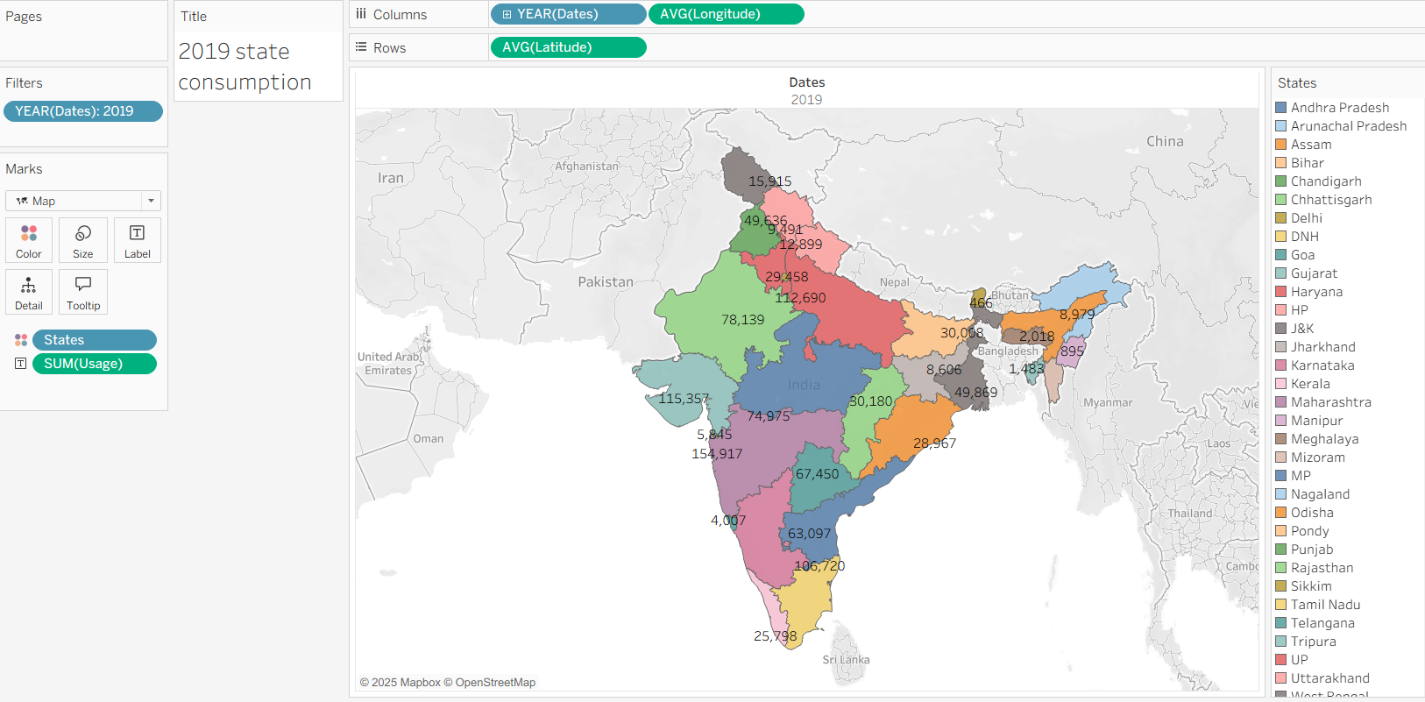

1. **2020 State Consumption**

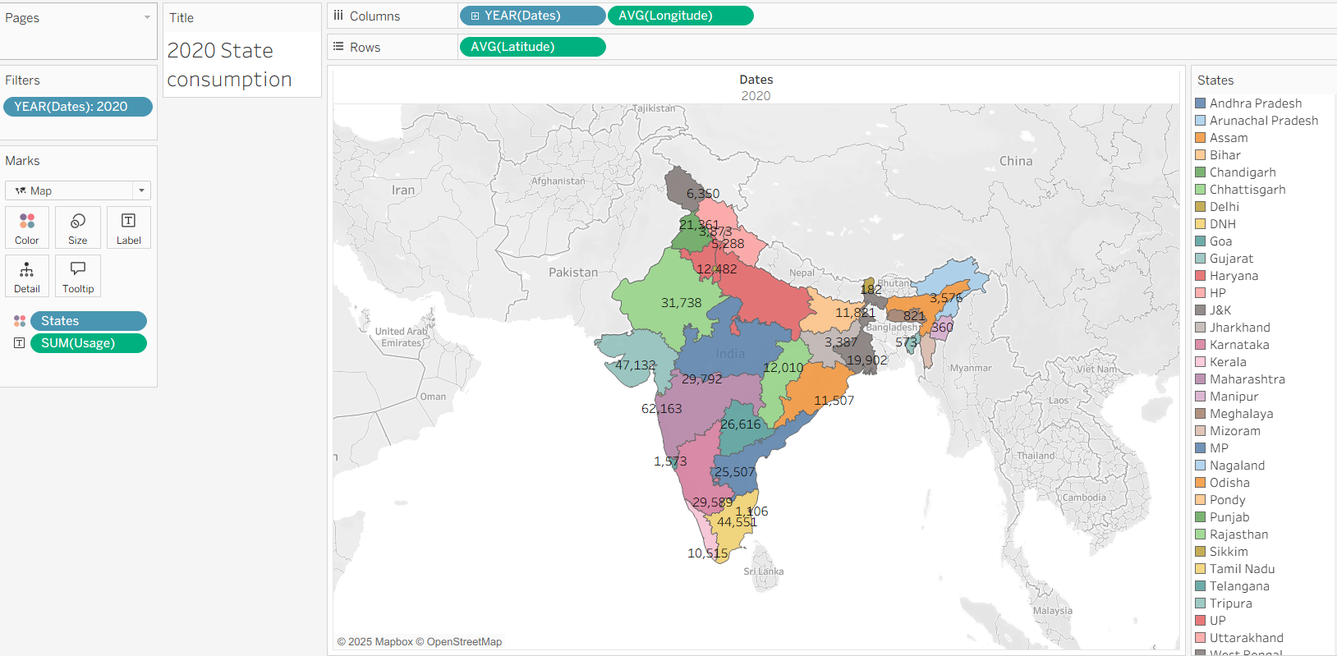

1. **Total Consumption**

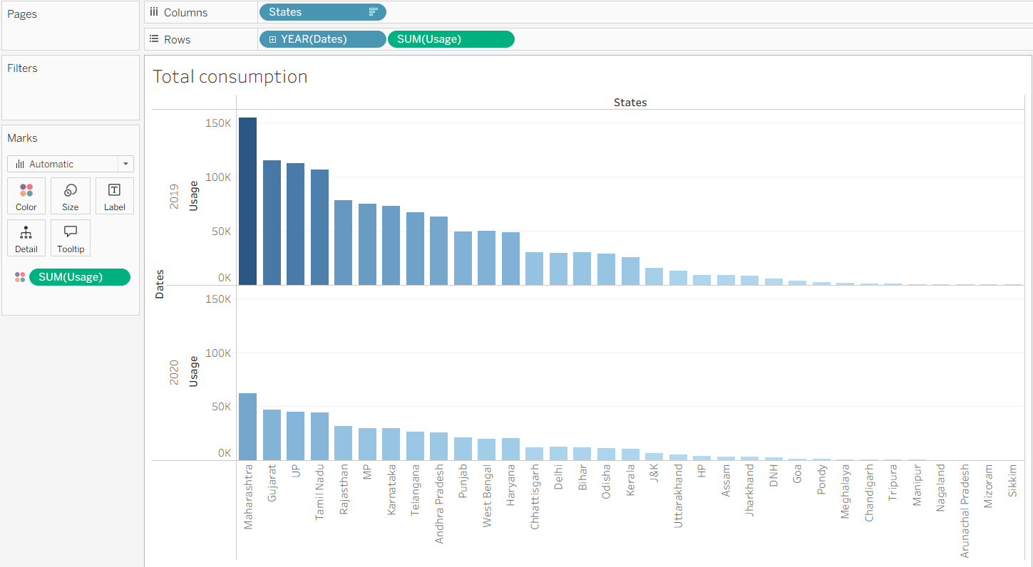

1. **Usage By Region**

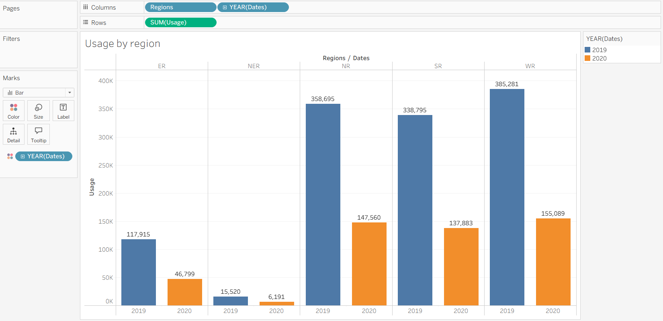

1. **Top N and Bottom N**

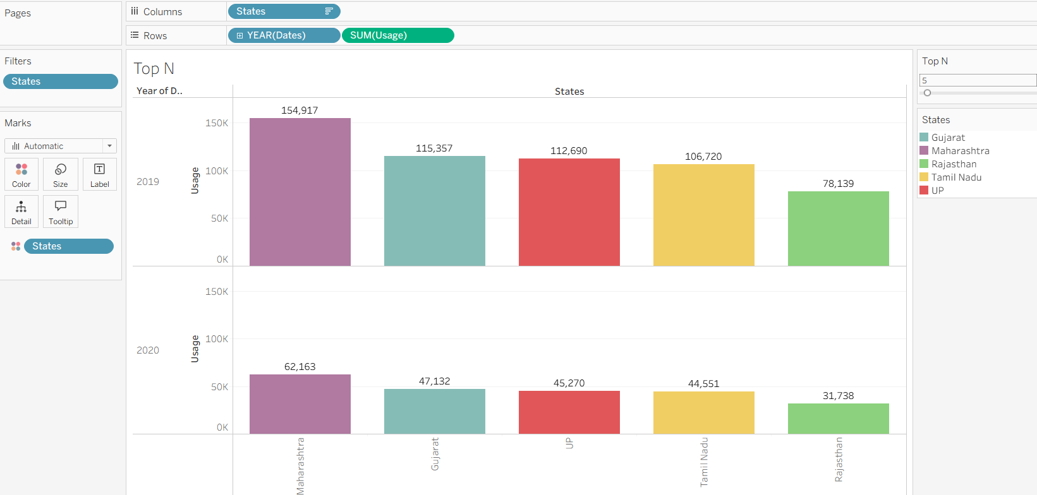

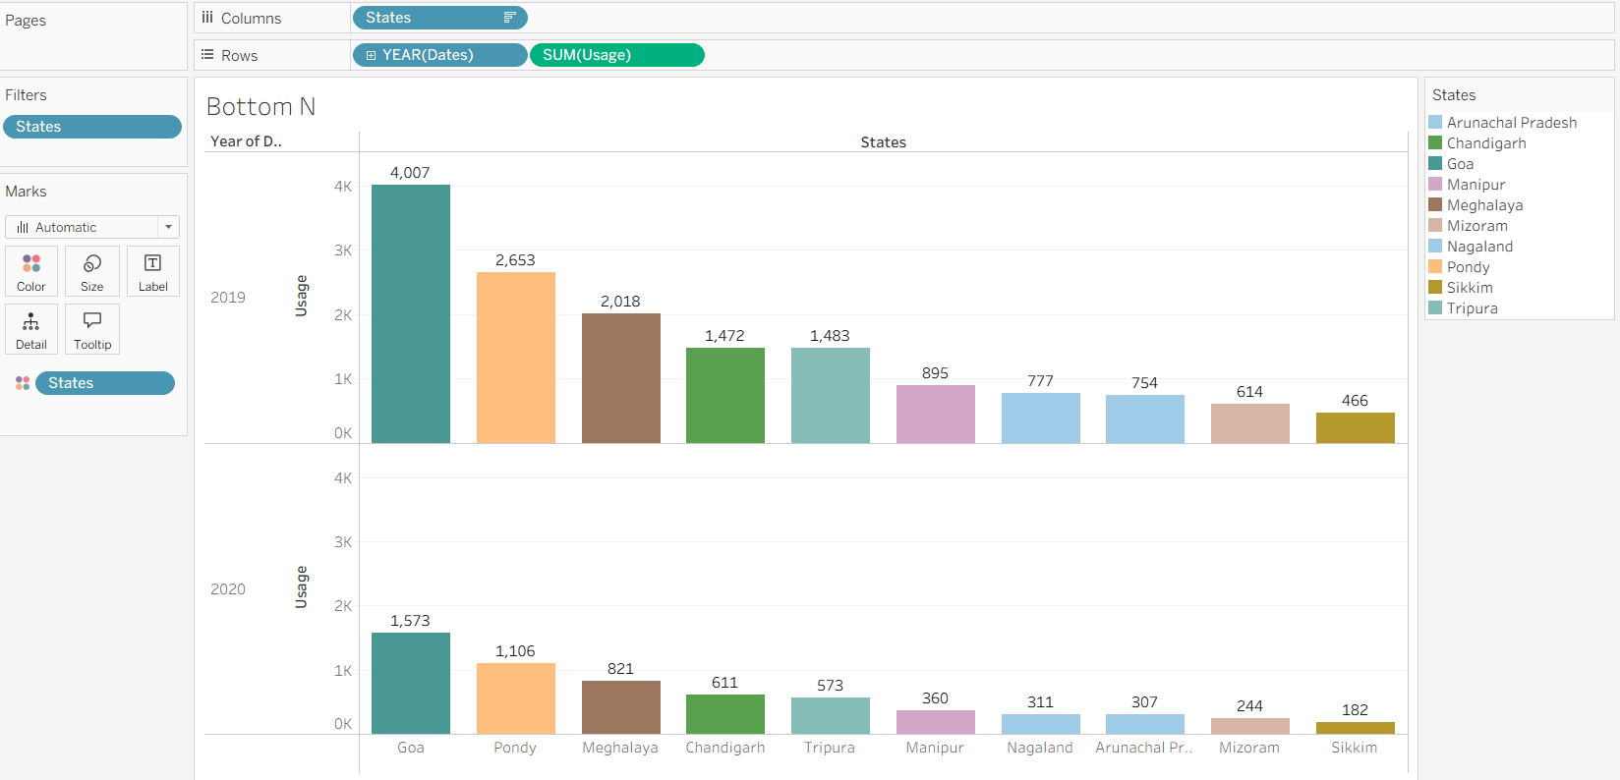

1. **2019 and 2020 Monthwise Consumption**

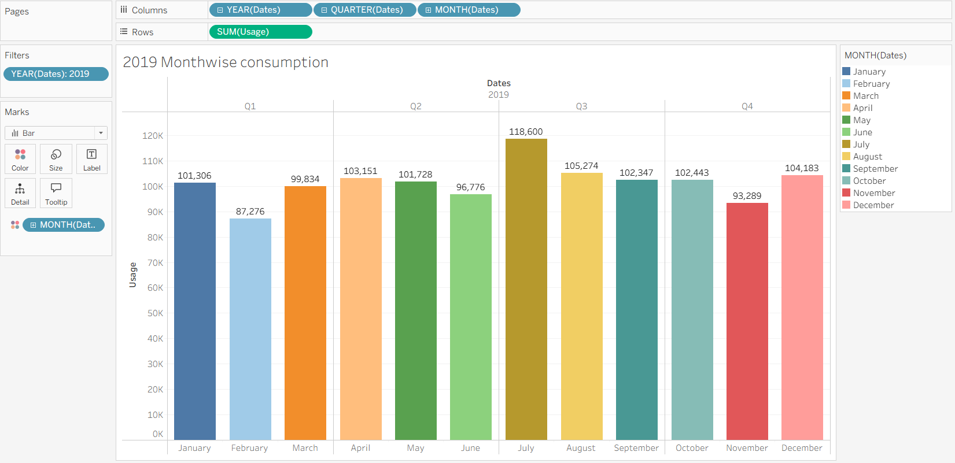

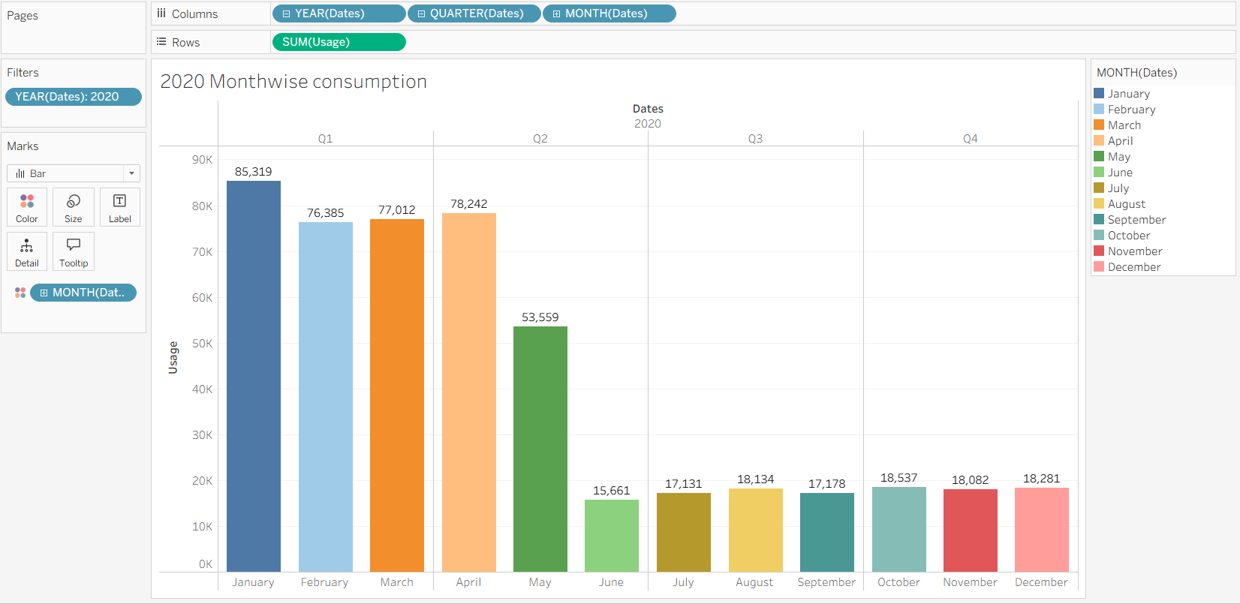

1. **Total Consumption Region Wise**

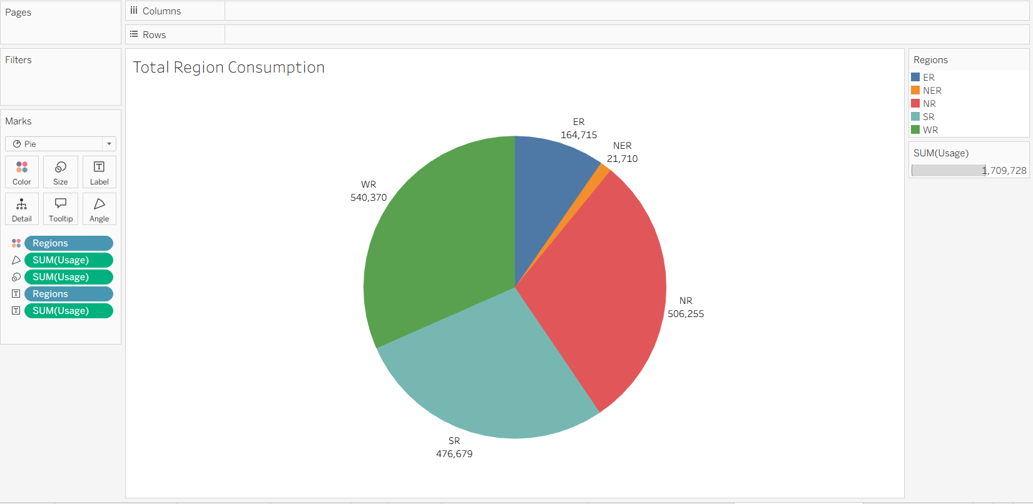

1. **Usage Before and After Lockdown**

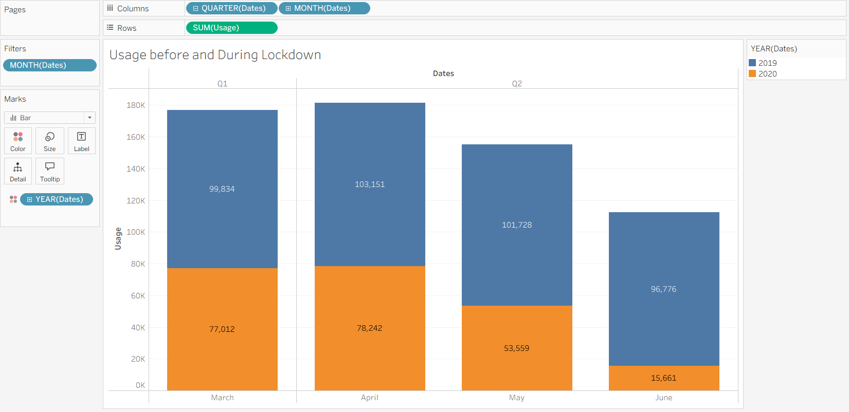

1. **Region wise State Usage**

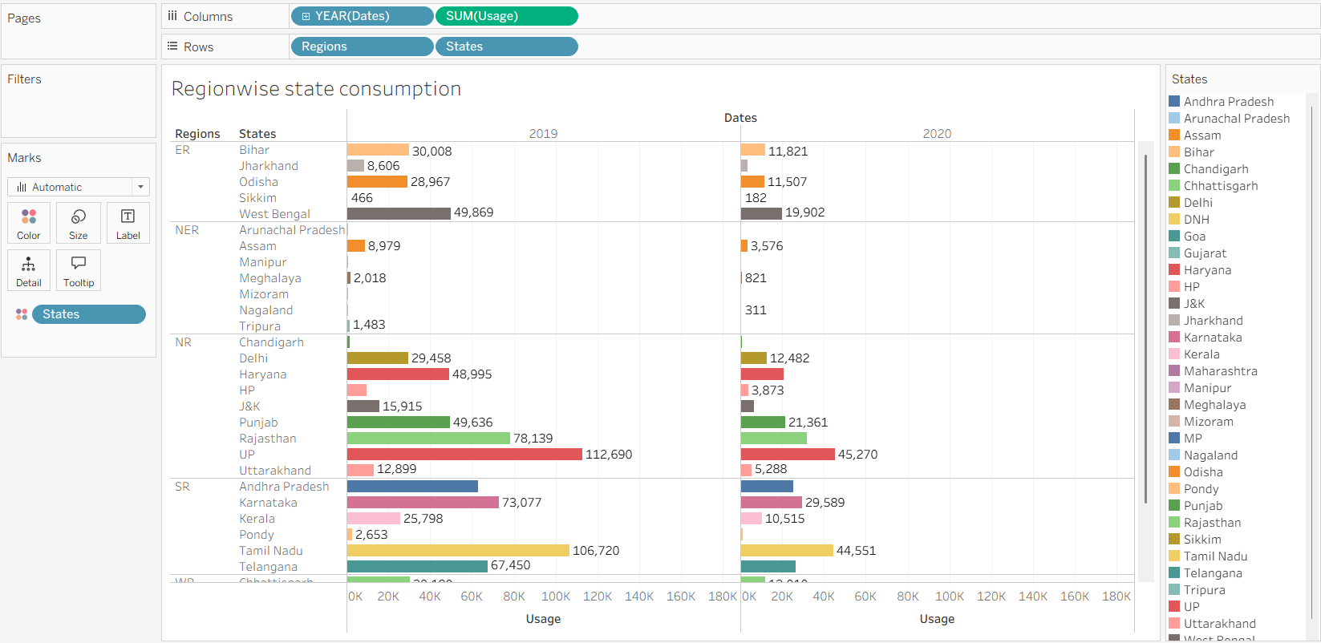

1. **Quarter Usage**

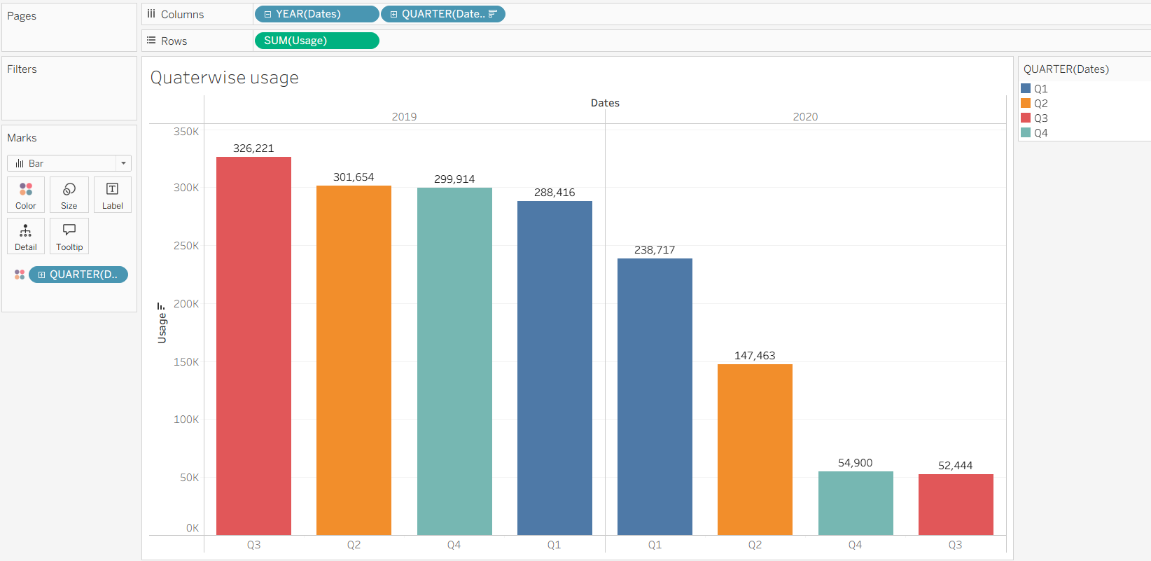

1. **Metro city  State usage**

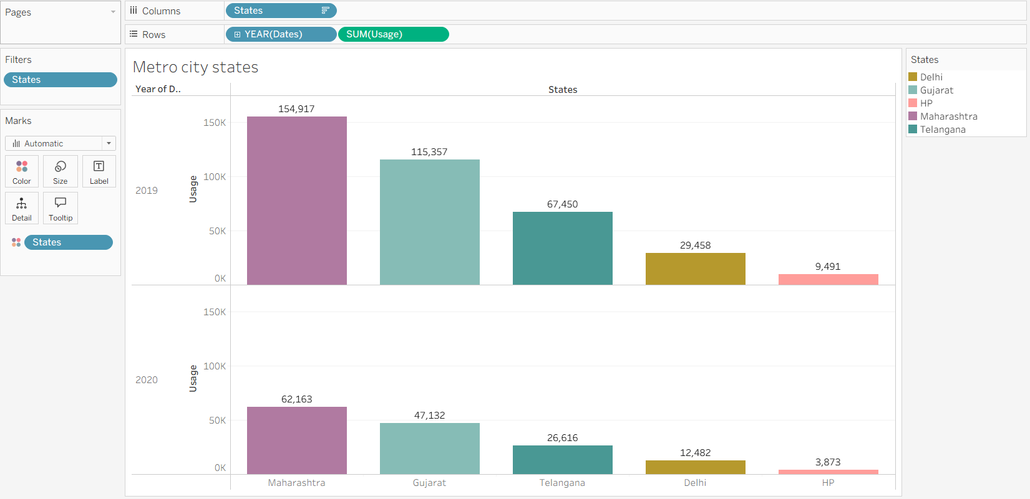

1. **Usage by year**

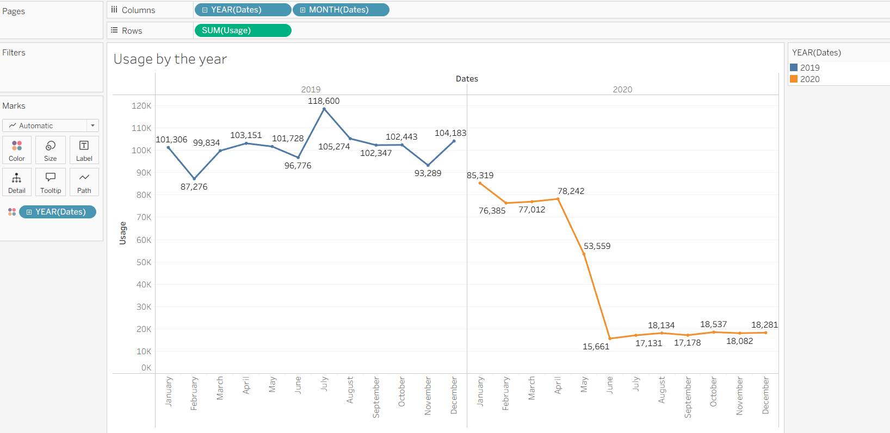

**Dashboard**

A dashboard is a graphical user interface (GUI) that displays information and data in an organized, easy-to-read format. Dashboards are often used to provide real-time monitoring and analysis of data, and are typically designed for a specific purpose or use case. Dashboards can be used in a variety of settings, such as business, finance, manufacturing, healthcare, and many other industries. They can be used to track key performance indicators (KPIs), monitor performance metrics, and display data in the form of charts, graphs, and tables.

**No of Unique Visualizations**

The responsiveness and design of a dashboard for analyzing the performance and efficiency of Radisson Hotels is crucial to ensure that the information is easily understandable and actionable. Key considerations for designing a responsive and effective dashboard include user-centered design, clear and concise information, interactivity, data-driven approach, accessibility, customization, and security. The goal is to create a dashboard that is user-friendly, interactive, and data-driven, providing actionable insights to improve the performance and efficiency of Radisson Hotels.  
Once you have created views on different sheets in Tableau, you can pull them into a dashboard.

**Dashboard 1:**

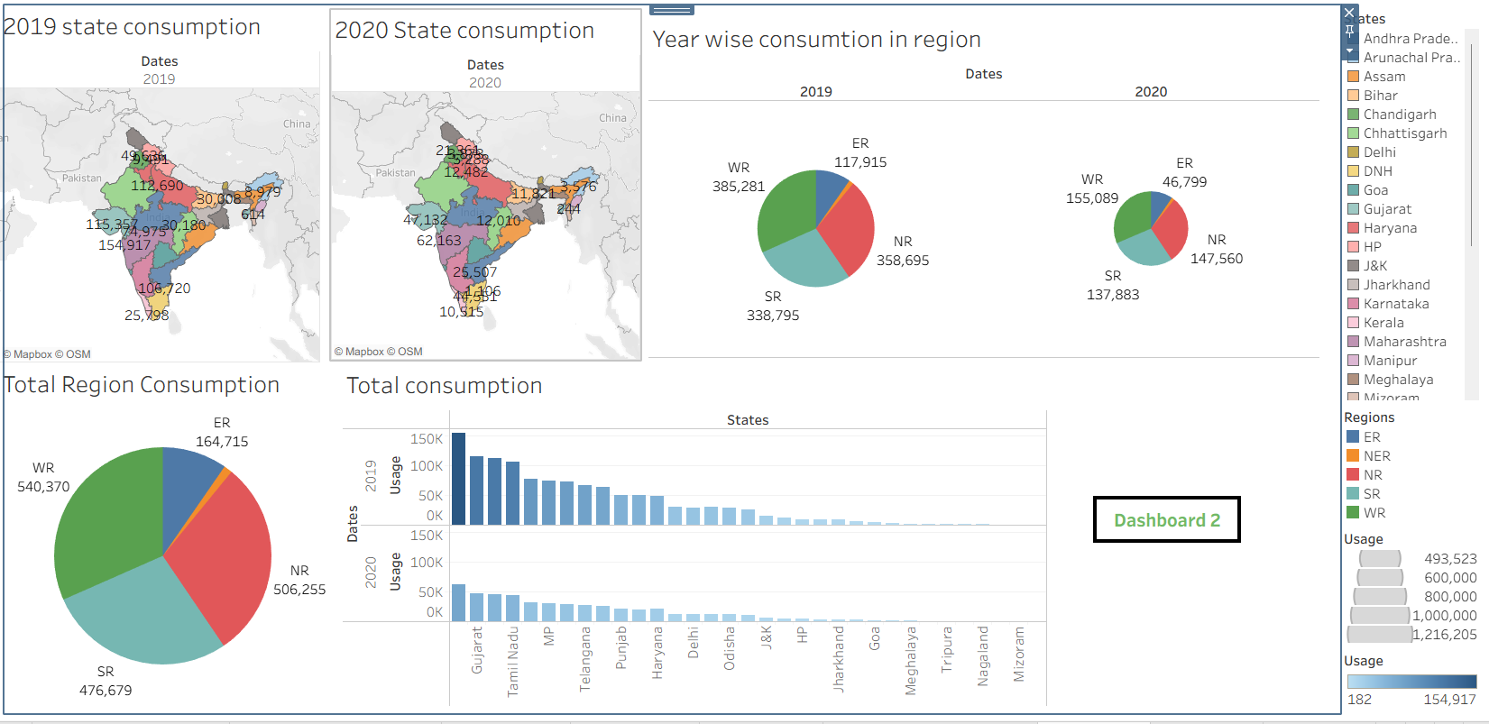

**Dashboard 2:**

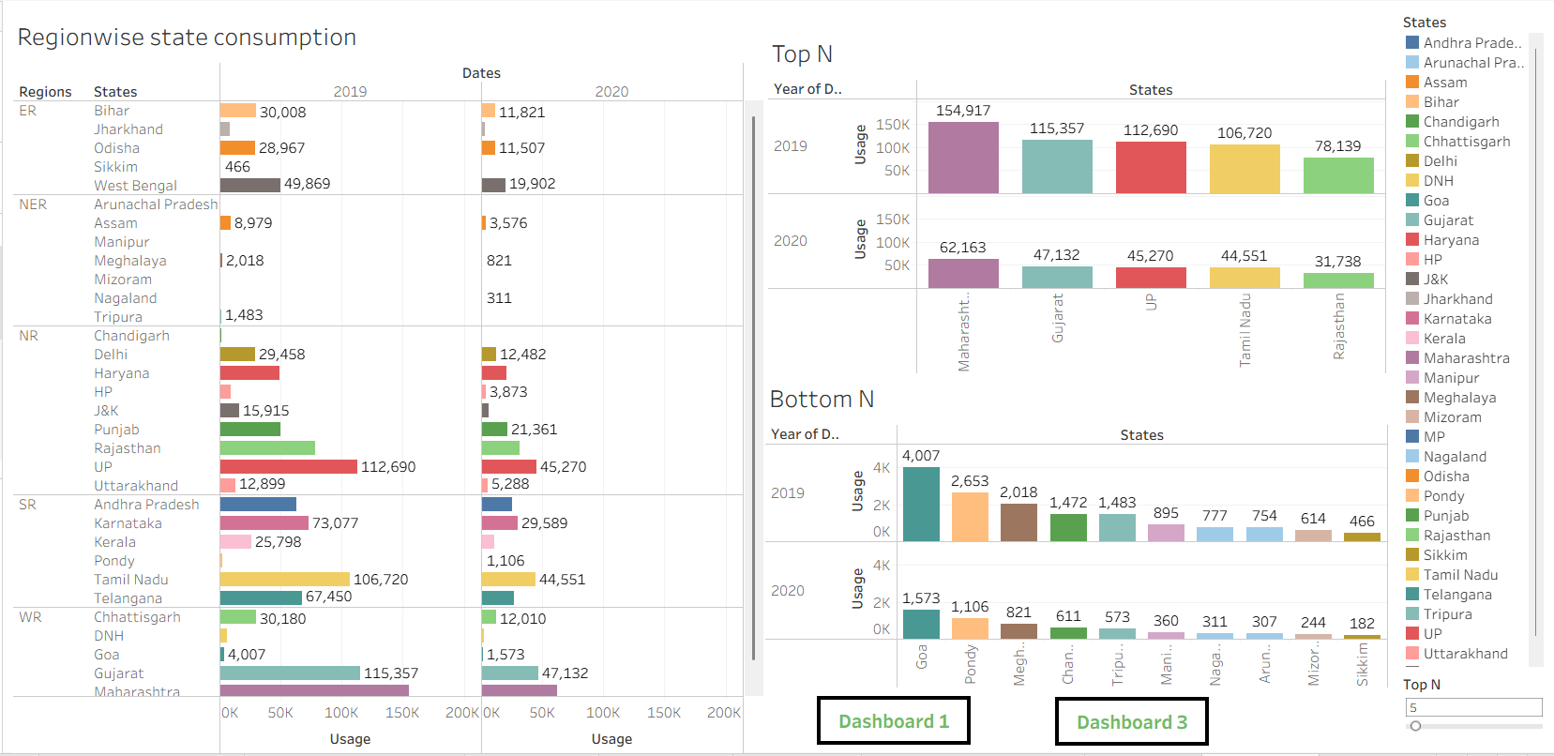

**Dashboard 3:**

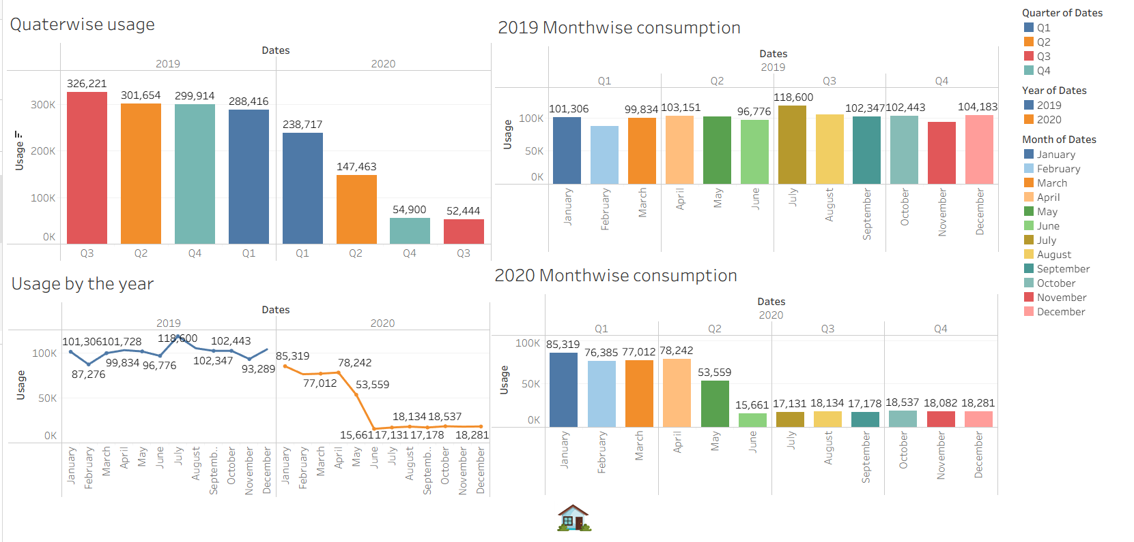

**Story**

A data story is a way of presenting data and analysis in a narrative format, with the goal of making the information more engaging and easier to understand. A data story typically includes a clear introduction that sets the stage and explains the context for the data, a body that presents the data and analysis in a logical and systematic way, and a conclusion that summarizes the key findings and highlights their implications. Data stories can be told using a variety of mediums, such as reports, presentations, interactive visualizations, and videos.

**Responsive and Design of Dashboard**

The number of scenes in a storyboard for a data visualization analysis of the electricity consumption in india will depend on the complexity of the analysis and the specific insights that are trying to be conveyed. A storyboard is a visual representation of the data analysis process and it breaks down the analysis into a series of steps or scenes.

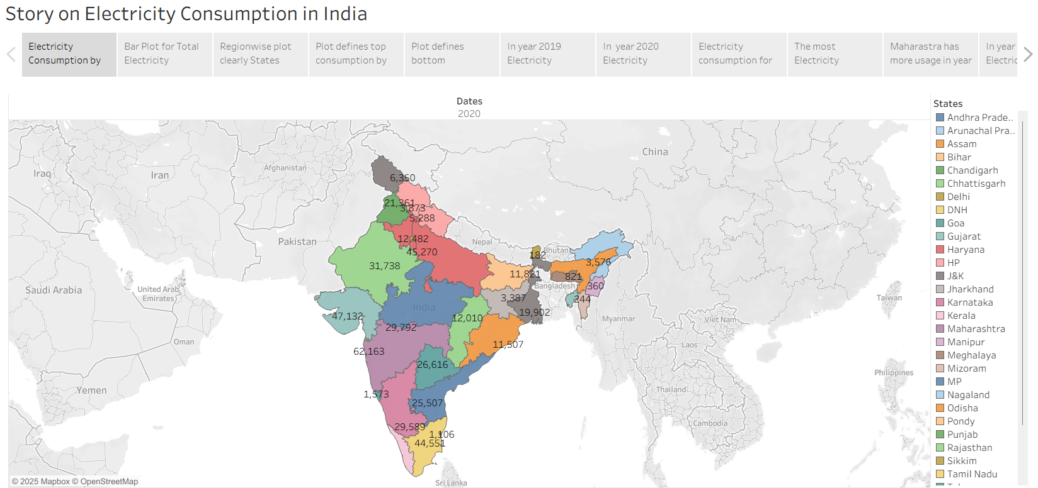

**Performance Testing**

**Amount of Data Rendered to DB**

The amount of data that is rendered to a database depends on the size of the dataset and the capacity of the database to store and retrieve data.   
Open the MySQL Workbench, go to the database then click to expand the tables, select the table and click on (i) button to get the information related to table such as column count, table rows etc.

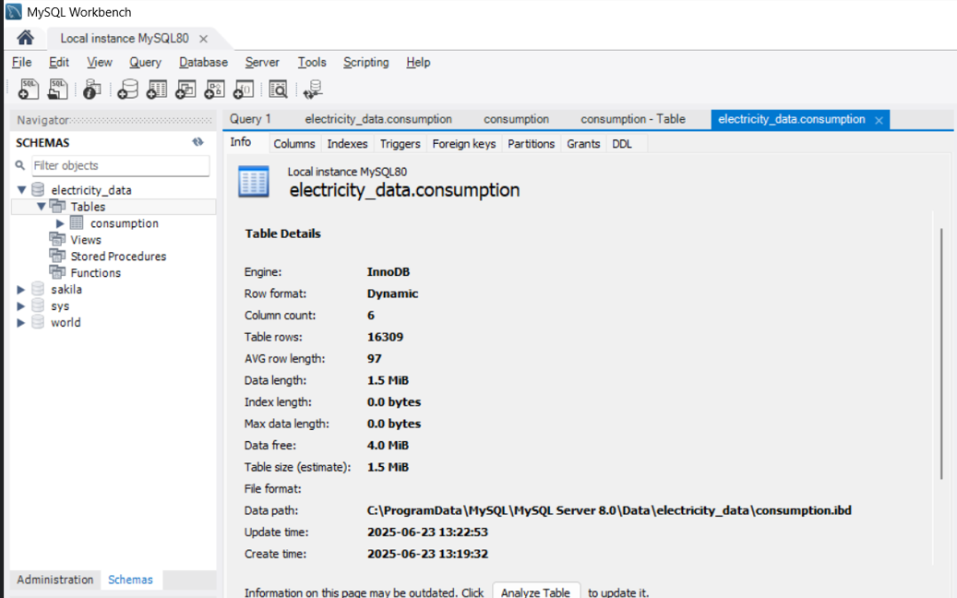

**No of Visualizations/ Graphs**

1. 2019 State Consumption
2. 2020 State Consumption
3. Total Consumption
4. Usage By Region
5. Top N and Bottom N
6. 2019 and 2020 Monthwise Consumption
7. Total Consumption Region Wise
8. Usage Before and After Lockdown
9. Region wise State Usage
10. Quarter Usage
11. Metro city  State usage
12. Usage by year

**Web integration**

Publishing helps us to track and monitor key performance metrics, to communicate results and progress. help a publisher stay informed, make better decisions, and communicate their performance to others.  
Publishing dashboard and reports to tableau public

**APP.py :-**

from flask import Flask, render_template, request

app = Flask(__name__)

@app.route("/")

def hello_world():

    return render_template('index.html')

if __name__ == '__main__':

    app.run(debug=False)

**index.html :-**

<!DOCTYPE html>

<html lang="en">

<head>

  <meta charset="utf-8">

  <meta content="width=device-width, initial-scale=1.0" name="viewport">

  <title>Electricity consumption analysis</title>

  <meta name="description" content="">

  <meta name="keywords" content="">

  <!-- Favicons -->

  <link href="/static/img/favicon.png" rel="icon">

  <link href="/static/img/apple-touch-icon.png" rel="apple-touch-icon">

  <!-- Fonts -->

  <link href="https://fonts.googleapis.com" rel="preconnect">

  <link href="https://fonts.g/static.com" rel="preconnect" crossorigin>

  <link href="https://fonts.googleapis.com/css2?family=Roboto:ital,wght@0,100;0,300;0,400;0,500;0,700;0,900;1,100;1,300;1,400;1,500;1,700;1,900&family=Poppins:ital,wght@0,100;0,200;0,300;0,400;0,500;0,600;0,700;0,800;0,900;1,100;1,200;1,300;1,400;1,500;1,600;1,700;1,800;1,900&family=Raleway:ital,wght@0,100;0,200;0,300;0,400;0,500;0,600;0,700;0,800;0,900;1,100;1,200;1,300;1,400;1,500;1,600;1,700;1,800;1,900&display=swap" rel="stylesheet">

  <!-- Vendor CSS Files -->

  <link href="/static/vendor/bootstrap/css/bootstrap.min.css" rel="stylesheet">

  <link href="/static/vendor/bootstrap-icons/bootstrap-icons.css" rel="stylesheet">

  <link href="/static/vendor/aos/aos.css" rel="stylesheet">

  <link href="/static/vendor/glightbox/css/glightbox.min.css" rel="stylesheet">

  <link href="/static/vendor/swiper/swiper-bundle.min.css" rel="stylesheet">

  <!-- Main CSS File -->

  <link href="/static/css/main.css" rel="stylesheet">

</head>

<body class="index-page">

  <header id="header" class="header d-flex align-items-center fixed-top">

    <div class="container-fluid container-xl position-relative d-flex align-items-center justify-content-between">

      <a href="index.html" class="logo d-flex align-items-center">

        <!-- Uncomment the line below if you also wish to use an image logo -->

        <!-- <img src="/static/img/logo.png" alt=""> -->

      </a>

      <nav id="navmenu" class="navmenu">

        <ul>

          <li><a href="#hero" class="active">Home</a></li>

          <li><a href="#about">About</a></li>

          <li><a href="#services">Story</a></li>

          <li><a href="#portfolio">Dashboard</a></li>

          <li><a href="#team">Visualizations</a></li>

        </ul>

        <i class="mobile-nav-toggle d-xl-none bi bi-list"></i>

      </nav>

    </div>

  </header>

  <main class="main">

    <!-- Hero Section -->

    <section id="hero" class="hero section accent-background">

          <img src="/static/img/hero-bg.webp" alt="" data-aos="fade-in">

      <div class="container text-center" data-aos="fade-up" data-aos-delay="100">

        <h2>WELCOME TO ENERGY INSIGHTS</h2>

        <p>ELECTRICITY CONSUMPTION ANALYSIS IN INDIA (2019 & 2020)</p>

        <a href="#about" class="btn-scroll" title="Scroll Down"><i class="bi bi-chevron-down"></i></a>

      </div>

    </section><!-- /Hero Section -->

    <!-- About Section -->

    <section id="about" class="about section">

      <div class="container">

        <div class="row gy-5">

          <div class="content col-xl-5 d-flex flex-column" data-aos="fade-up" data-aos-delay="100">

            <h3>Electricity Usage Insights & Trends</h3>

            <p>

              India's electricity demand and consumption patterns evolved significantly in 2019 and 2020. This analysis uncovers major trends across regions, sectors, and time periods.

            </p>

          </div>

          <div class="col-xl-7" data-aos="fade-up" data-aos-delay="200">

            <div class="row gy-4">

              <div class="col-md-6 icon-box position-relative">

                <h4><a href="" class="stretched-link">Consumption Overview</a></h4>

                <p>Review total electricity consumption across residential, commercial, and industrial sectors.</p>

              </div><!-- Icon-Box -->

              <div class="col-md-6 icon-box position-relative">

                <h4><a href="" class="stretched-link">Peak Load Patterns</a></h4>

                <p>Analyze daily and seasonal peak demand curves and grid response.</p>

              </div><!-- Icon-Box -->

              <div class="col-md-6 icon-box position-relative">

                <h4><a href="" class="stretched-link">Regional Comparison</a></h4>

                <p>Compare state-wise consumption to identify high and low usage areas.</p>

              </div><!-- Icon-Box -->

              <div class="col-md-6 icon-box position-relative">

                <h4><a href="" class="stretched-link">Impact of COVID-19</a></h4>

                <p>ESee how nationwide lockdowns in 2020 shifted usage patterns and reduced industrial demand.</p>

              </div><!-- Icon-Box -->

            </div>

          </div>

        </div>

      </div>

    </section><!-- /About Section -->

    <!-- Services Section -->

    <section id="services" class="services section">

      <!-- Section Title -->

      <div class="container section-title" data-aos="fade-up">

        <h2>Story</h2>

      </div><!-- End Section Title -->

      <div class='tableauPlaceholder' id='viz1750842903854' style="display: flex; justify-content: center; align-items: center; margin:auto; height: 100%;">

        <noscript>

          <div style="display: flex; justify-content: center; align-items: center; margin-left:600px ; height: 100%;">

            <a href='#'>

          <img alt='Story on Electricity Consumption in India ' src='https:&#47;&#47;public.tableau.com&#47;static&#47;images&#47;7H&#47;7HZD6WTW7&#47;1_rss.png' style='border: none' />

        </a></noscript>

        <object class='tableauViz'  style='display:none;'><param name='host_url' value='https%3A%2F%2Fpublic.tableau.com%2F' />

          <param name='embed_code_version' value='3' /> <param name='path' value='shared&#47;7HZD6WTW7' />

          <param name='toolbar' value='yes' /><param name='static_image' value='https:&#47;&#47;public.tableau.com&#47;static&#47;images&#47;7H&#47;7HZD6WTW7&#47;1.png' />

          <param name='animate_transition' value='yes' /><param name='display_static_image' value='yes' /><param name='display_spinner' value='yes' />

          <param name='display_overlay' value='yes' /><param name='display_count' value='yes' /><param name='language' value='en-US' />

          <param name='filter' value='publish=yes' />

        </object></div>

        <script type='text/javascript'>

        var divElement = document.getElementById('viz1750842903854');

        var vizElement = divElement.getElementsByTagName('object')[0];

        vizElement.style.width='1016px';vizElement.style.height='991px';

        var scriptElement = document.createElement('script');

        scriptElement.src = 'https://public.tableau.com/javascripts/api/viz_v1.js';

        vizElement.parentNode.insertBefore(scriptElement, vizElement);

        </script>

    </section><!-- /Services Section -->

    <!-- Portfolio Section -->

    <section id="portfolio" class="portfolio section">

      <!-- Section Title -->

      <div class="container section-title" data-aos="fade-up">

        <h2>Dashboard</h2>

        <p>Visualize and compare electricity consumption data across 2019 and 2020 — track trends, patterns, and anomalies in real-time through interactive charts and maps.</p>

      </div><!-- End Section Title -->

      <div class='tableauPlaceholder' id='viz1750844639761' style='position: relative'>

        <noscript>

          <a href='#'><img alt='Dashboard 1 ' src='https:&#47;&#47;public.tableau.com&#47;static&#47;images&#47;el&#47;electricityconsumption15&#47;Dashboard1&#47;1_rss.png' style='border: none' /></a>

        </noscript>

        <object class='tableauViz'  style='display:none;'>

          <param name='host_url' value='https%3A%2F%2Fpublic.tableau.com%2F' />

          <param name='embed_code_version' value='3' />

          <param name='site_root' value='' /><param name='name' value='electricityconsumption15&#47;Dashboard1' />

          <param name='tabs' value='no' /><param name='toolbar' value='yes' />

          <param name='static_image' value='https:&#47;&#47;public.tableau.com&#47;static&#47;images&#47;el&#47;electricityconsumption15&#47;Dashboard1&#47;1.png' />

          <param name='animate_transition' value='yes' />

          <param name='display_static_image' value='yes' />

          <param name='display_spinner' value='yes' />

          <param name='display_overlay' value='yes' />

          <param name='display_count' value='yes' />

          <param name='language' value='en-US' />

          <param name='filter' value='publish=yes' />

        </object></div>

        <script type='text/javascript'>

        var divElement = document.getElementById('viz1750844639761');

        var vizElement = divElement.getElementsByTagName('object')[0];

        if ( divElement.offsetWidth > 800 )

        {

          vizElement.style.width='100%';

          vizElement.style.height=(divElement.offsetWidth*0.75)+'px';

        }

        else if ( divElement.offsetWidth > 500 )

        {

          vizElement.style.width='100%';

          vizElement.style.height=(divElement.offsetWidth*0.75)+'px';

        }

        else

        {

        vizElement.style.width='100%';

        vizElement.style.height='1827px';

        }

        var scriptElement = document.createElement('script');

        scriptElement.src = 'https://public.tableau.com/javascripts/api/viz_v1.js';

        vizElement.parentNode.insertBefore(scriptElement, vizElement);

        </script>

    </section><!-- /Portfolio Section -->

    <!-- Team Section -->

    <section id="team" class="team section">

      <!-- Section Title -->

      <div class="container section-title" data-aos="fade-up">

        <h2>Visualizations</h2>

        <p>Explore interactive charts, bar graphs, line plots, and heatmaps that highlight monthly trends, sector-wise usage, and regional variations in electricity consumption during 2019 and 2020.</p>

      </div><!-- End Section Title -->

      <div class="container" data-aos="fade-up" data-aos-delay="100">

        <div class="row gy-5">

          <div class="col-xl-4 col-md-6 d-flex" data-aos="zoom-in" data-aos-delay="200">

            <div class="team-member">

              <div class="member-img">

                <img src="/static/img/team/2019 State Consumption.png" class="img-fluid" alt="">

              </div>

              <div class="member-info">

                 <h4>2019 State Consumption</h4>

              </div>

            </div>

          </div><!-- End Team Member -->

          <div class="col-xl-4 col-md-6 d-flex" data-aos="zoom-in" data-aos-delay="400">

            <div class="team-member">

              <div class="member-img">

                <img src="/static/img/team/2020 State Consumption.png" class="img-fluid" alt="">

              </div>

              <div class="member-info">

                <h4>2020 State Consumption</h4>

              </div>

            </div>

          </div><!-- End Team Member -->

          <div class="col-xl-4 col-md-6 d-flex" data-aos="zoom-in" data-aos-delay="600">

          <div class="team-member">

            <div class="member-img">

              <img src="/static/img/team/Bottom N.png" class="img-fluid" alt="">

            </div>

            <div class="member-info">

              <h4>Bottom N</h4>

            </div>

          </div>

        </div><!-- End Team Member -->

        <div class="col-xl-4 col-md-6 d-flex" data-aos="zoom-in" data-aos-delay="200">

          <div class="team-member">

            <div class="member-img">

              <img src="/static/img/team/Top N.png" class="img-fluid" alt="">

            </div>

            <div class="member-info">

              <h4>Top N</h4>

            </div>

          </div>

        </div><!-- End Team Member -->

          <div class="col-xl-4 col-md-6 d-flex" data-aos="zoom-in" data-aos-delay="400">

            <div class="team-member">

              <div class="member-img">

                <img src="/static/img/team/Total Consumption.png" class="img-fluid" alt="">

              </div>

              <div class="member-info">

                <h4>Total Consumption</h4>

              </div>

            </div>

          </div><!-- End Team Member -->

        <div class="col-xl-4 col-md-6 d-flex" data-aos="zoom-in" data-aos-delay="600">

          <div class="team-member">

            <div class="member-img">

              <img src="/static/img/team/Usage by Region.png" class="img-fluid" alt="">

            </div>

            <div class="member-info">

              <h4>Usage by Region</h4>

            </div>

          </div>

        </div><!-- End Team Member -->

        <div class="col-xl-4 col-md-6 d-flex" data-aos="zoom-in" data-aos-delay="200">

          <div class="team-member">

            <div class="member-img">

              <img src="/static/img/team/2019 Monthwise Consumption.png" class="img-fluid" alt="">

            </div>

            <div class="member-info">

              <h4>2019 Monthwise Consumption</h4>

            </div>

          </div>

        </div><!-- End Team Member -->

        <div class="col-xl-4 col-md-6 d-flex" data-aos="zoom-in" data-aos-delay="400">

          <div class="team-member">

            <div class="member-img">

              <img src="/static/img/team/2020 Monthwise Consumption.png" class="img-fluid" alt="">

            </div>

            <div class="member-info">

              <h4>2020 Monthwise Consumption</h4>

            </div>

          </div>

        </div><!-- End Team Member -->

        <div class="col-xl-4 col-md-6 d-flex" data-aos="zoom-in" data-aos-delay="600">

          <div class="team-member">

            <div class="member-img">

              <img src="/static/img/team/Total Region Consumption.png" class="img-fluid" alt="">

            </div>

            <div class="member-info">

              <h4>Total Region Consumption</h4>

            </div>

          </div>

        </div><!-- End Team Member -->

        <div class="col-xl-4 col-md-6 d-flex" data-aos="zoom-in" data-aos-delay="200">

          <div class="team-member">

            <div class="member-img">

              <img src="/static/img/team/Usage Before and During Lockdown.png" class="img-fluid" alt="">

            </div>

            <div class="member-info">

              <h4>Usage Before and During Lockdown</h4>

            </div>

          </div>

        </div><!-- End Team Member -->

        <div class="col-xl-4 col-md-6 d-flex" data-aos="zoom-in" data-aos-delay="400">

          <div class="team-member">

            <div class="member-img">

              <img src="/static/img/team/Monthwise Top Consumption.png" class="img-fluid" alt="">

            </div>

            <div class="member-info">

              <h4>Monthwise Top Consumption</h4>

            </div>

          </div>

        </div><!-- End Team Member -->

        <div class="col-xl-4 col-md-6 d-flex" data-aos="zoom-in" data-aos-delay="600">

          <div class="team-member">

            <div class="member-img">

              <img src="/static/img/team/Regionwise State Consumption.png" class="img-fluid" alt="">

            </div>

            <div class="member-info">

              <h4>Regionwise State Consumption</h4>

            </div>

          </div>

        </div><!-- End Team Member -->

        <div class="col-xl-4 col-md-6 d-flex" data-aos="zoom-in" data-aos-delay="200">

          <div class="team-member">

            <div class="member-img">

              <img src="/static/img/team/Quarterwise Usage.png" class="img-fluid" alt="">

            </div>

            <div class="member-info">

              <h4>Quarterwise Usage</h4>

            </div>

          </div>

        </div><!-- End Team Member -->

        <div class="col-xl-4 col-md-6 d-flex" data-aos="zoom-in" data-aos-delay="400">

          <div class="team-member">

            <div class="member-img">

              <img src="/static/img/team/Usage by the Year.png" class="img-fluid" alt="">

            </div>

            <div class="member-info">

              <h4>Usage by the Year</h4>

            </div>

          </div>

        </div><!-- End Team Member -->

        <div class="col-xl-4 col-md-6 d-flex" data-aos="zoom-in" data-aos-delay="600">

          <div class="team-member">

            <div class="member-img">

              <img src="/static/img/team/Metro City States.png" class="img-fluid" alt="">

            </div>

            <div class="member-info">

              <h4>Metro City States</h4>

            </div>

          </div>

        </div><!-- End Team Member -->

        <div class="col-xl-4 col-md-6 d-flex" data-aos="zoom-in" data-aos-delay="200">

          <div class="team-member">

            <div class="member-img">

              <img src="/static/img/team/Yearwise Consumption in Region.png" class="img-fluid" alt="">

            </div>

            <div class="member-info">

              <h4>Yearwise Consumption in Region</h4>

            </div>

          </div>

        </div><!-- End Team Member -->

      </div>

    </main>

  <!-- Scroll Top -->

  <a href="#" id="scroll-top" class="scroll-top d-flex align-items-center justify-content-center"><i class="bi bi-arrow-up-short"></i></a>

  <!-- Preloader -->

  <div id="preloader"></div>

  <!-- Vendor JS Files -->

  <script src="/static/vendor/bootstrap/js/bootstrap.bundle.min.js"></script>

  <script src="/static/vendor/php-email-form/validate.js"></script>

  <script src="/static/vendor/aos/aos.js"></script>

  <script src="/static/vendor/purecounter/purecounter_vanilla.js"></script>

  <script src="/static/vendor/glightbox/js/glightbox.min.js"></script>

  <script src="/static/vendor/imagesloaded/imagesloaded.pkgd.min.js"></script>

  <script src="/static/vendor/isotope-layout/isotope.pkgd.min.js"></script>

  <script src="/static/vendor/swiper/swiper-bundle.min.js"></script>

  <!-- Main JS File -->

  <script src="/static/js/main.js"></script>

</body>

</html>

**Main.css :-**

:root {

  --default-font: "Roboto",  system-ui, -apple-system, "Segoe UI", Roboto, "Helvetica Neue", Arial, "Noto Sans", "Liberation Sans", sans-serif, "Apple Color Emoji", "Segoe UI Emoji", "Segoe UI Symbol", "Noto Color Emoji";

  --heading-font: "Raleway",  sans-serif;

  --nav-font: "Poppins",  sans-serif;

}

/* Global Colors - The following color variables are used throughout the website. Updating them here will change the color scheme of the entire website */

:root {

  --background-color: #ffffff; /* Background color for the entire website, including individual sections */

  --default-color: #444444; /* Default color used for the majority of the text content across the entire website */

  --heading-color: #2f4d5a; /* Color for headings, subheadings and title throughout the website */

  --accent-color: #67b0d1; /* Accent color that represents your brand on the website. It's used for buttons, links, and other elements that need to stand out */

  --surface-color: #ffffff; /* The surface color is used as a background of boxed elements within sections, such as cards, icon boxes, or other elements that require a visual separation from the global background. */

  --contrast-color: #ffffff; /* Contrast color for text, ensuring readability against backgrounds of accent, heading, or default colors. */

}

/* Nav Menu Colors - The following color variables are used specifically for the navigation menu. They are separate from the global colors to allow for more customization options */

:root {

  --nav-color: #ffffff;  /* The default color of the main navmenu links */

  --nav-hover-color: #67b0d1; /* Applied to main navmenu links when they are hovered over or active */

  --nav-mobile-background-color: #ffffff; /* Used as the background color for mobile navigation menu */

  --nav-dropdown-background-color: #ffffff; /* Used as the background color for dropdown items that appear when hovering over primary navigation items */

  --nav-dropdown-color: #444444; /* Used for navigation links of the dropdown items in the navigation menu. */

  --nav-dropdown-hover-color: #67b0d1; /* Similar to --nav-hover-color, this color is applied to dropdown navigation links when they are hovered over. */

}

/* Color Presets - These classes override global colors when applied to any section or element, providing reuse of the sam color scheme. */

.light-background {

  --background-color: #f5f9fc;

  --surface-color: #ffffff;

}

.dark-background {

  --background-color: #273f49;

  --default-color: #ffffff;

  --heading-color: #ffffff;

  --surface-color: #395c6a;

  --contrast-color: #ffffff;

}

.accent-background {

  --background-color: #67b0d1;

  --default-color: #ffffff;

  --heading-color: #ffffff;

  --surface-color: #8ec4dd;

}

/* Smooth scroll */

:root {

  scroll-behavior: smooth;

}

/*--------------------------------------------------------------

# General Styling & Shared Classes

--------------------------------------------------------------*/

body {

  color: var(--default-color);

  background-color: var(--background-color);

  font-family: var(--default-font);

}

a {

  color: var(--accent-color);

  text-decoration: none;

  transition: 0.3s;

}

a:hover {

  color: color-mix(in srgb, var(--accent-color), transparent 25%);

  text-decoration: none;

}

h1,

h2,

h3,

h4,

h5,

h6 {

  color: var(--heading-color);

  font-family: var(--heading-font);

}

/* PHP Email Form Messages

------------------------------*/

.php-email-form .error-message {

  display: none;

  background: #df1529;

  color: #ffffff;

  text-align: left;

  padding: 15px;

  margin-bottom: 24px;

  font-weight: 600;

}

.php-email-form .sent-message {

  display: none;

  color: #ffffff;

  background: #059652;

  text-align: center;

  padding: 15px;

  margin-bottom: 24px;

  font-weight: 600;

}

.php-email-form .loading {

  display: none;

  background: var(--surface-color);

  text-align: center;

  padding: 15px;

  margin-bottom: 24px;

}

.php-email-form .loading:before {

  content: "";

  display: inline-block;

  border-radius: 50%;

  width: 24px;

  height: 24px;

  margin: 0 10px -6px 0;

  border: 3px solid var(--accent-color);

  border-top-color: var(--surface-color);

  animation: php-email-form-loading 1s linear infinite;

}

@keyframes php-email-form-loading {

  0% {

    transform: rotate(0deg);

  }

  100% {

    transform: rotate(360deg);

  }

}

/*--------------------------------------------------------------

# Global Header

--------------------------------------------------------------*/

.header {

  --background-color: rgba(255, 255, 255, 0);

  --default-color: #ffffff;

  --heading-color: #ffffff;

  color: var(--default-color);

  background-color: var(--background-color);

  padding: 15px 0;

  transition: all 0.5s;

  z-index: 997;

}

.header .logo {

  line-height: 1;

}

.header .logo img {

  max-height: 32px;

  margin-right: 8px;

}

.header .logo h1 {

  font-size: 26px;

  margin: 0;

  font-weight: 700;

  color: var(--heading-color);

  text-transform: uppercase;

}

.scrolled .header {

  box-shadow: 0px 0 18px rgba(0, 0, 0, 0.1);

}

/* Global Header on Scroll

------------------------------*/

.scrolled .header {

  --background-color: #4b99bb;

}

/*--------------------------------------------------------------

# Navigation Menu

--------------------------------------------------------------*/

/* Desktop Navigation */

@media (min-width: 1200px) {

  .navmenu {

    padding: 0;

  }

  .navmenu ul {

    margin: 0;

    padding: 0;

    display: flex;

    list-style: none;

    align-items: center;

  }

  .navmenu li {

    position: relative;

  }

  .navmenu a,

  .navmenu a:focus {

    color: var(--nav-color);

    padding: 10px 15px;

    margin-left: 2px;

    font-size: 16px;

    font-family: var(--nav-font);

    font-weight: 500;

    display: flex;

    align-items: center;

    justify-content: space-between;

    white-space: nowrap;

    transition: 0.3s;

  }

  .navmenu a i,

  .navmenu a:focus i {

    font-size: 12px;

    line-height: 0;

    margin-left: 5px;

    transition: 0.3s;

  }

  .navmenu li:hover>a,

  .navmenu .active,

  .navmenu .active:focus {

    color: var(--contrast-color);

    background-color: var(--nav-hover-color);

  }

  .navmenu .dropdown ul {

    margin: 0;

    padding: 0;

    background: var(--nav-dropdown-background-color);

    display: block;

    position: absolute;

    visibility: hidden;

    left: 2px;

    top: 130%;

    opacity: 0;

    transition: 0.3s;

    z-index: 99;

    box-shadow: 0px 0px 30px rgba(0, 0, 0, 0.1);

  }

  .navmenu .dropdown ul li {

    min-width: 200px;

  }

  .navmenu .dropdown ul a {

    padding: 10px 20px;

    margin: 0;

    font-size: 15px;

    text-transform: none;

    color: var(--nav-dropdown-color);

  }

  .navmenu .dropdown ul a i {

    font-size: 12px;

  }

  .navmenu .dropdown ul a:hover,

  .navmenu .dropdown ul .active:hover,

  .navmenu .dropdown ul li:hover>a {

    color: var(--contrast-color);

    background-color: var(--nav-hover-color);

  }

  .navmenu .dropdown:hover>ul {

    opacity: 1;

    top: 100%;

    visibility: visible;

  }

  .navmenu .dropdown .dropdown ul {

    top: 0;

    left: -90%;

    visibility: hidden;

  }

  .navmenu .dropdown .dropdown:hover>ul {

    opacity: 1;

    top: 0;

    left: -100%;

    visibility: visible;

  }

}

/* Mobile Navigation */

@media (max-width: 1199px) {

  .mobile-nav-toggle {

    color: var(--nav-color);

    font-size: 28px;

    line-height: 0;

    margin-right: 10px;

    cursor: pointer;

    transition: color 0.3s;

  }

  .navmenu {

    padding: 0;

    z-index: 9997;

  }

  .navmenu ul {

    display: none;

    list-style: none;

    position: absolute;

    inset: 60px 20px 20px 20px;

    padding: 10px 0;

    margin: 0;

    border-radius: 6px;

    background-color: var(--nav-mobile-background-color);

    overflow-y: auto;

    transition: 0.3s;

    z-index: 9998;

    box-shadow: 0px 0px 30px rgba(0, 0, 0, 0.1);

  }

  .navmenu a,

  .navmenu a:focus {

    color: var(--nav-dropdown-color);

    padding: 10px 20px;

    font-family: var(--nav-font);

    font-size: 17px;

    font-weight: 500;

    display: flex;

    align-items: center;

    justify-content: space-between;

    white-space: nowrap;

    transition: 0.3s;

  }

  .navmenu a i,

  .navmenu a:focus i {

    font-size: 12px;

    line-height: 0;

    margin-left: 5px;

    width: 30px;

    height: 30px;

    display: flex;

    align-items: center;

    justify-content: center;

    border-radius: 50%;

    transition: 0.3s;

    background-color: color-mix(in srgb, var(--accent-color), transparent 90%);

  }

  .navmenu a i:hover,

  .navmenu a:focus i:hover {

    background-color: var(--accent-color);

    color: var(--contrast-color);

  }

  .navmenu a:hover,

  .navmenu .active,

  .navmenu .active:focus {

    color: var(--nav-dropdown-hover-color);

  }

  .navmenu .active i,

  .navmenu .active:focus i {

    background-color: var(--accent-color);

    color: var(--contrast-color);

    transform: rotate(180deg);

  }

  .navmenu .dropdown ul {

    position: static;

    display: none;

    z-index: 99;

    padding: 10px 0;

    margin: 10px 20px;

    background-color: var(--nav-dropdown-background-color);

    border: 1px solid color-mix(in srgb, var(--default-color), transparent 90%);

    box-shadow: none;

    transition: all 0.5s ease-in-out;

  }

  .navmenu .dropdown ul ul {

    background-color: rgba(33, 37, 41, 0.1);

  }

  .navmenu .dropdown>.dropdown-active {

    display: block;

    background-color: rgba(33, 37, 41, 0.03);

  }

  .mobile-nav-active {

    overflow: hidden;

  }

  .mobile-nav-active .mobile-nav-toggle {

    color: #fff;

    position: absolute;

    font-size: 32px;

    top: 15px;

    right: 15px;

    margin-right: 0;

    z-index: 9999;

  }

  .mobile-nav-active .navmenu {

    position: fixed;

    overflow: hidden;

    inset: 0;

    background: rgba(33, 37, 41, 0.8);

    transition: 0.3s;

  }

  .mobile-nav-active .navmenu>ul {

    display: block;

  }

}

/*--------------------------------------------------------------

# Global Footer

--------------------------------------------------------------*/

.footer {

  color: var(--default-color);

  background-color: var(--background-color);

  font-size: 14px;

  position: relative;

}

.footer .footer-top {

  padding-top: 50px;

  border-top: 1px solid color-mix(in srgb, var(--default-color), transparent 90%);

}

.footer .footer-about .logo {

  line-height: 1;

  margin-bottom: 25px;

}

.footer .footer-about .logo img {

  max-height: 40px;

  margin-right: 6px;

}

.footer .footer-about .logo span {

  font-size: 26px;

  font-weight: 700;

  letter-spacing: 1px;

  font-family: var(--heading-font);

  color: var(--heading-color);

}

.footer .footer-about p {

  font-size: 14px;

  font-family: var(--heading-font);

}

.footer .social-links a {

  display: flex;

  align-items: center;

  justify-content: center;

  width: 40px;

  height: 40px;

  border-radius: 50%;

  border: 1px solid color-mix(in srgb, var(--default-color), transparent 50%);

  font-size: 16px;

  color: color-mix(in srgb, var(--default-color), transparent 30%);

  margin-right: 10px;

  transition: 0.3s;

}

.footer .social-links a:hover {

  color: var(--accent-color);

  border-color: var(--accent-color);

}

.footer h4 {

  font-size: 16px;

  font-weight: bold;

  position: relative;

  padding-bottom: 12px;

}

.footer .footer-links {

  margin-bottom: 30px;

}

.footer .footer-links ul {

  list-style: none;

  padding: 0;

  margin: 0;

}

.footer .footer-links ul i {

  padding-right: 2px;

  font-size: 12px;

  line-height: 0;

}

.footer .footer-links ul li {

  padding: 10px 0;

  display: flex;

  align-items: center;

}

.footer .footer-links ul li:first-child {

  padding-top: 0;

}

.footer .footer-links ul a {

  color: color-mix(in srgb, var(--default-color), transparent 30%);

  display: inline-block;

  line-height: 1;

}

.footer .footer-links ul a:hover {

  color: var(--accent-color);

}

.footer .footer-contact p {

  margin-bottom: 5px;

}

.footer .footer-newsletter .newsletter-form {

  margin-top: 30px;

  margin-bottom: 15px;

  padding: 6px 8px;

  position: relative;

  border-radius: 4px;

  border: 1px solid color-mix(in srgb, var(--default-color), transparent 80%);

  display: flex;

  background-color: var(--background-color);

  transition: 0.3s;

}

.footer .footer-newsletter .newsletter-form:focus-within {

  border-color: var(--accent-color);

}

.footer .footer-newsletter .newsletter-form input[type=email] {

  border: 0;

  padding: 4px;

  width: 100%;

  background-color: var(--background-color);

  color: var(--default-color);

}

.footer .footer-newsletter .newsletter-form input[type=email]:focus-visible {

  outline: none;

}

.footer .footer-newsletter .newsletter-form input[type=submit] {

  border: 0;

  font-size: 16px;

  padding: 0 20px;

  margin: -7px -8px -7px 0;

  background: var(--accent-color);

  color: var(--contrast-color);

  transition: 0.3s;

  border-radius: 0 4px 4px 0;

}

.footer .footer-newsletter .newsletter-form input[type=submit]:hover {

  background: color-mix(in srgb, var(--accent-color), transparent 20%);

}

.footer .copyright {

  padding: 25px 0;

  border-top: 1px solid color-mix(in srgb, var(--default-color), transparent 90%);

}

.footer .copyright p {

  margin-bottom: 0;

}

.footer .credits {

  margin-top: 6px;

  font-size: 13px;

}

/*--------------------------------------------------------------

# Preloader

--------------------------------------------------------------*/

#preloader {

  position: fixed;

  inset: 0;

  z-index: 999999;

  overflow: hidden;

  background: var(--background-color);

  transition: all 0.6s ease-out;

}

#preloader:before {

  content: "";

  position: fixed;

  top: calc(50% - 30px);

  left: calc(50% - 30px);

  border: 6px solid #ffffff;

  border-color: var(--accent-color) transparent var(--accent-color) transparent;

  border-radius: 50%;

  width: 60px;

  height: 60px;

  animation: animate-preloader 1.5s linear infinite;

}

@keyframes animate-preloader {

  0% {

    transform: rotate(0deg);

  }

  100% {

    transform: rotate(360deg);

  }

}

/*--------------------------------------------------------------

# Scroll Top Button

--------------------------------------------------------------*/

.scroll-top {

  position: fixed;

  visibility: hidden;

  opacity: 0;

  right: 15px;

  bottom: -15px;

  z-index: 99999;

  background-color: var(--accent-color);

  width: 44px;

  height: 44px;

  border-radius: 50px;

  transition: all 0.4s;

}

.scroll-top i {

  font-size: 24px;

  color: var(--contrast-color);

  line-height: 0;

}

.scroll-top:hover {

  background-color: color-mix(in srgb, var(--accent-color), transparent 20%);

  color: var(--contrast-color);

}

.scroll-top.active {

  visibility: visible;

  opacity: 1;

  bottom: 15px;

}

/*--------------------------------------------------------------

# Disable aos animation delay on mobile devices

--------------------------------------------------------------*/

@media screen and (max-width: 768px) {

  [data-aos-delay] {

    transition-delay: 0 !important;

  }

}

/*--------------------------------------------------------------

# Global Page Titles & Breadcrumbs

--------------------------------------------------------------*/

.page-title {

  color: var(--default-color);

  background-color: var(--background-color);

  padding: 160px 0 80px 0;

  text-align: center;

  position: relative;

}

.page-title:before {

  content: "";

  background-color: color-mix(in srgb, var(--background-color), transparent 50%);

  position: absolute;

  inset: 0;

}

.page-title h1 {

  font-size: 42px;

  font-weight: 700;

  margin-bottom: 10px;

}

.page-title .breadcrumbs ol {

  display: flex;

  flex-wrap: wrap;

  list-style: none;

  justify-content: center;

  padding: 0;

  margin: 0;

  font-size: 16px;

  font-weight: 400;

}

.page-title .breadcrumbs ol li+li {

  padding-left: 10px;

}

.page-title .breadcrumbs ol li+li::before {

  content: "/";

  display: inline-block;

  padding-right: 10px;

  color: color-mix(in srgb, var(--default-color), transparent 50%);

}

/*--------------------------------------------------------------

# Global Sections

--------------------------------------------------------------*/

section,

.section {

  color: var(--default-color);

  background-color: var(--background-color);

  padding: 60px 0;

  scroll-margin-top: 74px;

  overflow: clip;

}

@media (max-width: 1199px) {

  section,

  .section {

    scroll-margin-top: 82px;

  }

}

/*--------------------------------------------------------------

# Global Section Titles

--------------------------------------------------------------*/

.section-title {

  text-align: center;

  padding-bottom: 60px;

  position: relative;

}

.section-title h2 {

  font-size: 32px;

  font-weight: 700;

  margin-bottom: 15px;

  position: relative;

  z-index: 1;

}

.section-title h2::after {

  content: "";

  position: absolute;

  left: 50%;

  top: 50%;

  transform: translate(-50%, -50%);

  width: 122px;

  height: 66px;

  background: url(../img/section-title-bg.png) no-repeat;

  z-index: -1;

}

.section-title p {

  margin-bottom: 0;

}

/*--------------------------------------------------------------

# Hero Section

--------------------------------------------------------------*/

.hero {

  width: 100%;

  min-height: 100vh;

  position: relative;

  padding: 120px 0 60px 0;

  display: flex;

  align-items: center;

  justify-content: center;

}

.hero:before {

  content: "";

  background: color-mix(in srgb, var(--background-color), transparent 70%);

  position: absolute;

  inset: 0;

  z-index: 2;

}

.hero img {

  position: absolute;

  inset: 0;

  display: block;

  width: 100%;

  height: 100%;

  object-fit: cover;

  z-index: 1;

}

.hero .container {

  position: relative;

  z-index: 3;

}

.hero h2 {

  margin: 0;

  font-size: 48px;

  font-weight: 700;

  line-height: 56px;

  text-transform: uppercase;

  text-shadow: -1px 0 2px #2f4d5a;

}

.hero p {

  color: var(--default-color);

  margin: 10px 0 0 0;

  font-size: 20px;

  font-weight: 700;

  letter-spacing: 1px;

  text-transform: uppercase;

  text-shadow: -1px 0 2px #2f4d5a;

}

@media (max-width: 640px) {

  .hero h1 {

    font-size: 30px;

    line-height: 36px;

  }

}

.hero .btn-scroll {

  transition: 0.4s;

  color: var(--default-color);

  display: block;

  margin-top: 30px;

  animation: btn-up-down 1s ease-in-out infinite alternate-reverse both;

}

.hero .btn-scroll i {

  font-size: 48px;

}

.hero .btn-scroll:hover {

  color: var(--accent-color);

}

@keyframes btn-up-down {

  0% {

    transform: translateY(5px);

  }

  100% {

    transform: translateY(-5px);

  }

}

/*--------------------------------------------------------------

# About Section

--------------------------------------------------------------*/

.about .content h3 {

  font-weight: 700;

  font-size: 34px;

  margin-bottom: 30px;

}

.about .content p {

  margin-bottom: 30px;

}

.about .content .about-btn {

  padding: 8px 30px 9px 30px;

  color: var(--accent-color);

  border-radius: 50px;

  transition: 0.3s;

  text-transform: uppercase;

  font-weight: 600;

  font-size: 13px;

  display: inline-flex;

  align-items: center;

  border: 2px solid var(--accent-color);

}

.about .content .about-btn i {

  font-size: 16px;

  padding-left: 5px;

}

.about .content .about-btn:hover {

  background: var(--accent-color);

  color: var(--contrast-color);

}

.about .icon-box i {

  font-size: 40px;

  color: var(--accent-color);

  margin-bottom: 10px;

}

.about .icon-box h4 {

  font-size: 20px;

  font-weight: 700;

  margin: 0 0 10px 0;

}

.about .icon-box h4 a {

  color: var(--heading-color);

  transition: 0.3s;

}

.about .icon-box p {

  font-size: 15px;

  color: color-mix(in srgb, var(--default-color), transparent 40%);

  margin-bottom: 0;

}

.about .icon-box:hover h4 a {

  color: var(--accent-color);

}

/*--------------------------------------------------------------

# Services Section

--------------------------------------------------------------*/

.services .service-item {

  background-color: var(--surface-color);

  box-shadow: 0px 0 25px 0 rgba(0, 0, 0, 0.1);

  padding: 50px 30px;

  transition: all 0.3s ease-in-out;

  height: 100%;

  position: relative;

  z-index: 1;

}

.services .service-item:before {

  content: "";

  position: absolute;

  background: var(--accent-color);

  inset: 100% 0 0 0;

  transition: all 0.3s;

  z-index: -1;

}

.services .service-item .icon {

  margin-bottom: 10px;

}

.services .service-item .icon i {

  color: var(--accent-color);

  font-size: 36px;

  transition: ease-in-out 0.3s;

}

.services .service-item h4 {

  font-weight: 700;

  margin-bottom: 15px;

  font-size: 20px;

}

.services .service-item h4 a {

  color: var(--heading-color);

  transition: ease-in-out 0.3s;

}

.services .service-item p {

  line-height: 24px;

  font-size: 14px;

  margin-bottom: 0;

  transition: ease-in-out 0.3s;

}

.services .service-item:hover h4 a,

.services .service-item:hover .icon i,

.services .service-item:hover p {

  color: var(--contrast-color);

}

.services .service-item:hover:before {

  background: var(--accent-color);

  inset: 0;

  border-radius: 0px;

}

/*--------------------------------------------------------------

# Portfolio Section

--------------------------------------------------------------*/

.portfolio .portfolio-filters {

  padding: 0;

  margin: 0 auto 20px auto;

  list-style: none;

  text-align: center;

}

.portfolio .portfolio-filters li {

  cursor: pointer;

  display: inline-block;

  padding: 0;

  font-size: 16px;

  font-weight: 600;

  margin: 0 10px;

  line-height: 1;

  text-transform: uppercase;

  margin-bottom: 5px;

  transition: all 0.3s ease-in-out;

}

.portfolio .portfolio-filters li:hover,

.portfolio .portfolio-filters li.filter-active {

  color: var(--accent-color);

}

.portfolio .portfolio-filters li:first-child {

  margin-left: 0;

}

.portfolio .portfolio-filters li:last-child {

  margin-right: 0;

}

@media (max-width: 575px) {

  .portfolio .portfolio-filters li {

    font-size: 14px;

    margin: 0 5px;

  }

}

.portfolio .portfolio-item {

  position: relative;

}

.portfolio .portfolio-item .portfolio-info {

  background-color: color-mix(in srgb, var(--surface-color), transparent 10%);

  opacity: 0;

  position: absolute;

  left: 30px;

  right: 30px;

  bottom: 0;

  z-index: 3;

  transition: all ease-in-out 0.3s;

  padding: 15px;

}

.portfolio .portfolio-item .portfolio-info h4 {

  font-size: 18px;

  font-weight: 600;

  padding-right: 50px;

}

.portfolio .portfolio-item .portfolio-info p {

  color: color-mix(in srgb, var(--default-color), transparent 30%);

  font-size: 14px;

  margin-bottom: 0;

  padding-right: 50px;

}

.portfolio .portfolio-item .portfolio-info .preview-link,

.portfolio .portfolio-item .portfolio-info .details-link {

  position: absolute;

  right: 50px;

  font-size: 24px;

  top: calc(50% - 14px);

  color: color-mix(in srgb, var(--default-color), transparent 30%);

  transition: 0.3s;

  line-height: 0;

}

.portfolio .portfolio-item .portfolio-info .preview-link:hover,

.portfolio .portfolio-item .portfolio-info .details-link:hover {

  color: var(--accent-color);

}

.portfolio .portfolio-item .portfolio-info .details-link {

  right: 14px;

  font-size: 28px;

}

.portfolio .portfolio-item:hover .portfolio-info {

  opacity: 1;

  bottom: 20px;

}

/*--------------------------------------------------------------

# Team Section

--------------------------------------------------------------*/

.team .team-member .member-img {

  border-radius: 8px;

  overflow: hidden;

}

.team .team-member .social {

  position: absolute;

  left: 0;

  top: -18px;

  right: 0;

  opacity: 0;

  transition: ease-in-out 0.3s;

  display: flex;

  align-items: center;

  justify-content: center;

}

.team .team-member .social a {

  transition: color 0.3s;

  color: var(--contrast-color);

  background: var(--accent-color);

  margin: 0 5px;

  display: inline-flex;

  align-items: center;

  justify-content: center;

  width: 36px;

  height: 36px;

  border-radius: 50%;

  transition: 0.3s;

}

.team .team-member .social a i {

  line-height: 0;

  font-size: 16px;

}

.team .team-member .social a:hover {

  background: color-mix(in srgb, var(--accent-color) 90%, black 15%);

}

.team .team-member .social i {

  font-size: 18px;

  margin: 0 2px;

}

.team .team-member .member-info {

  background-color: var(--surface-color);

  padding: 30px 15px;

  text-align: center;

  box-shadow: 0px 2px 15px rgba(0, 0, 0, 0.1);

  background: var(--surface-color);

  margin: -50px 20px 0 20px;

  position: relative;

  border-radius: 8px;

}

.team .team-member .member-info h4 {

  font-weight: 500;

  margin-bottom: 5px;

  font-size: 20px;

}

.team .team-member .member-info span {

  display: block;

  font-size: 16px;

  font-weight: 400;

  color: color-mix(in srgb, var(--default-color), transparent 30%);

}

.team .team-member .member-info p {

  font-style: italic;

  font-size: 14px;

  line-height: 26px;

  color: color-mix(in srgb, var(--default-color), transparent 30%);

}

.team .team-member:hover .social {

  opacity: 1;

}

/*--------------------------------------------------------------

# Portfolio Details Section

--------------------------------------------------------------*/

.portfolio-details .portfolio-details-slider img {

  width: 100%;

}

.portfolio-details .portfolio-details-slider .swiper-pagination {

  margin-top: 20px;

  position: relative;

}

.portfolio-details .portfolio-details-slider .swiper-pagination .swiper-pagination-bullet {

  width: 12px;

  height: 12px;

  background-color: color-mix(in srgb, var(--default-color), transparent 85%);

  opacity: 1;

}

.portfolio-details .portfolio-details-slider .swiper-pagination .swiper-pagination-bullet-active {

  background-color: var(--accent-color);

}

.portfolio-details .portfolio-info {

  background-color: var(--surface-color);

  padding: 30px;

  box-shadow: 0px 0 30px rgba(0, 0, 0, 0.1);

}

.portfolio-details .portfolio-info h3 {

  font-size: 22px;

  font-weight: 700;

  margin-bottom: 20px;

  padding-bottom: 20px;

  border-bottom: 1px solid color-mix(in srgb, var(--default-color), transparent 85%);

}

.portfolio-details .portfolio-info ul {

  list-style: none;

  padding: 0;

  font-size: 15px;

}

.portfolio-details .portfolio-info ul li+li {

  margin-top: 10px;

}

.portfolio-details .portfolio-description {

  padding-top: 30px;

}

.portfolio-details .portfolio-description h2 {

  font-size: 26px;

  font-weight: 700;

  margin-bottom: 20px;

}

.portfolio-details .portfolio-description p {

  padding: 0;

  color: color-mix(in srgb, var(--default-color), transparent 30%);

}

/*--------------------------------------------------------------

# Service Details Section

--------------------------------------------------------------*/

.service-details .services-list {

  background-color: var(--surface-color);

  padding: 10px 30px;

  border: 1px solid color-mix(in srgb, var(--default-color), transparent 90%);

  margin-bottom: 20px;

}

.service-details .services-list a {

  display: block;

  line-height: 1;

  padding: 8px 0 8px 15px;

  border-left: 3px solid color-mix(in srgb, var(--default-color), transparent 70%);

  margin: 20px 0;

  color: color-mix(in srgb, var(--default-color), transparent 20%);

  transition: 0.3s;

}

.service-details .services-list a.active {

  color: var(--heading-color);

  font-weight: 700;

  border-color: var(--accent-color);

}

.service-details .services-list a:hover {

  border-color: var(--accent-color);

}

.service-details .services-img {

  margin-bottom: 20px;

}

.service-details h3 {

  font-size: 26px;

  font-weight: 700;

}

.service-details h4 {

  font-size: 20px;

  font-weight: 700;

}

.service-details p {

  font-size: 15px;

}

.service-details ul {

  list-style: none;

  padding: 0;

  font-size: 15px;

}

.service-details ul li {

  padding: 5px 0;

  display: flex;

  align-items: center;

}

.service-details ul i {

  font-size: 20px;

  margin-right: 8px;

  color: var(--accent-color);

}

**Main.js :-**

(function() {

  "use strict";

  /**

   * Apply .scrolled class to the body as the page is scrolled down

   */

  function toggleScrolled() {

    const selectBody = document.querySelector('body');

    const selectHeader = document.querySelector('#header');

    if (!selectHeader.classList.contains('scroll-up-sticky') && !selectHeader.classList.contains('sticky-top') && !selectHeader.classList.contains('fixed-top')) return;

    window.scrollY > 100 ? selectBody.classList.add('scrolled') : selectBody.classList.remove('scrolled');

  }

  document.addEventListener('scroll', toggleScrolled);

  window.addEventListener('load', toggleScrolled);

  /**

   * Mobile nav toggle

   */

  const mobileNavToggleBtn = document.querySelector('.mobile-nav-toggle');

  function mobileNavToogle() {

    document.querySelector('body').classList.toggle('mobile-nav-active');

    mobileNavToggleBtn.classList.toggle('bi-list');

    mobileNavToggleBtn.classList.toggle('bi-x');

  }

  mobileNavToggleBtn.addEventListener('click', mobileNavToogle);

  /**

   * Hide mobile nav on same-page/hash links

   */

  document.querySelectorAll('#navmenu a').forEach(navmenu => {

    navmenu.addEventListener('click', () => {

      if (document.querySelector('.mobile-nav-active')) {

        mobileNavToogle();

      }

    });

  });

  /**

   * Toggle mobile nav dropdowns

   */

  document.querySelectorAll('.navmenu .toggle-dropdown').forEach(navmenu => {

    navmenu.addEventListener('click', function(e) {

      e.preventDefault();

      this.parentNode.classList.toggle('active');

      this.parentNode.nextElementSibling.classList.toggle('dropdown-active');

      e.stopImmediatePropagation();

    });

  });

  /**

   * Preloader

   */

  const preloader = document.querySelector('#preloader');

  if (preloader) {

    window.addEventListener('load', () => {

      preloader.remove();

    });

  }

  /**

   * Scroll top button

   */

  let scrollTop = document.querySelector('.scroll-top');

  function toggleScrollTop() {

    if (scrollTop) {

      window.scrollY > 100 ? scrollTop.classList.add('active') : scrollTop.classList.remove('active');

    }

  }

  scrollTop.addEventListener('click', (e) => {

    e.preventDefault();

    window.scrollTo({

      top: 0,

      behavior: 'smooth'

    });

  });

  window.addEventListener('load', toggleScrollTop);

  document.addEventListener('scroll', toggleScrollTop);

  /**

   * Animation on scroll function and init

   */

  function aosInit() {

    AOS.init({

      duration: 600,

      easing: 'ease-in-out',

      once: true,

      mirror: false

    });

  }

  window.addEventListener('load', aosInit);

  /**

   * Initiate Pure Counter

   */

  new PureCounter();

  /**

   * Initiate glightbox

   */

  const glightbox = GLightbox({

    selector: '.glightbox'

  });

  /**

   * Init isotope layout and filters

   */

  document.querySelectorAll('.isotope-layout').forEach(function(isotopeItem) {

    let layout = isotopeItem.getAttribute('data-layout') ?? 'masonry';

    let filter = isotopeItem.getAttribute('data-default-filter') ?? '*';

    let sort = isotopeItem.getAttribute('data-sort') ?? 'original-order';

    let initIsotope;

    imagesLoaded(isotopeItem.querySelector('.isotope-container'), function() {

      initIsotope = new Isotope(isotopeItem.querySelector('.isotope-container'), {

        itemSelector: '.isotope-item',

        layoutMode: layout,

        filter: filter,

        sortBy: sort

      });

    });

    isotopeItem.querySelectorAll('.isotope-filters li').forEach(function(filters) {

      filters.addEventListener('click', function() {

        isotopeItem.querySelector('.isotope-filters .filter-active').classList.remove('filter-active');

        this.classList.add('filter-active');

        initIsotope.arrange({

          filter: this.getAttribute('data-filter')

        });

        if (typeof aosInit === 'function') {

          aosInit();

        }

      }, false);

    });

  });

  /**

   * Init swiper sliders

   */

  function initSwiper() {

    document.querySelectorAll(".init-swiper").forEach(function(swiperElement) {

      let config = JSON.parse(

        swiperElement.querySelector(".swiper-config").innerHTML.trim()

      );

      if (swiperElement.classList.contains("swiper-tab")) {

        initSwiperWithCustomPagination(swiperElement, config);

      } else {

        new Swiper(swiperElement, config);

      }

    });

  }

  window.addEventListener("load", initSwiper);

  /**

   * Correct scrolling position upon page load for URLs containing hash links.

   */

  window.addEventListener('load', function(e) {

    if (window.location.hash) {

      if (document.querySelector(window.location.hash)) {

        setTimeout(() => {

          let section = document.querySelector(window.location.hash);

          let scrollMarginTop = getComputedStyle(section).scrollMarginTop;

          window.scrollTo({

            top: section.offsetTop - parseInt(scrollMarginTop),

            behavior: 'smooth'

          });

        }, 100);

      }

    }

  });

  /**

   * Navmenu Scrollspy

   */

  let navmenulinks = document.querySelectorAll('.navmenu a');

  function navmenuScrollspy() {

    navmenulinks.forEach(navmenulink => {

      if (!navmenulink.hash) return;

      let section = document.querySelector(navmenulink.hash);

      if (!section) return;

      let position = window.scrollY + 200;

      if (position >= section.offsetTop && position <= (section.offsetTop + section.offsetHeight)) {

        document.querySelectorAll('.navmenu a.active').forEach(link => link.classList.remove('active'));

        navmenulink.classList.add('active');

      } else {

        navmenulink.classList.remove('active');

      }

    })

  }

  window.addEventListener('load', navmenuScrollspy);

  document.addEventListener('scroll', navmenuScrollspy);

})();

**OUTPUT:-**

